**Industrial Internship Report on**

**”smart water meter** **”**

**Prepared by**

**Deeksha G A**

|  |
| --- |
| *Executive Summary* |
| This report provides details of the Industrial Internship provided by upskill Campus and The IoT Academy in collaboration with Industrial Partner UniConverge Technologies Pvt Ltd (UCT).  This internship was focused on a project/problem statement provided by UCT. We had to finish the project including the report in 6 weeks’ time.  My project is about smart water meter  Increasing water consumption and wastage are leading to water scarcity. While a large population has no safe drinking water, some people use a lot of water daily and waste it. Develop a project related to the Smart Water meter System which can be used to calculate the flow rate and quantity of water consumed by the householders and send it to the cloud to monitor the consumption of water.  This internship gave me a very good opportunity to get exposure to Industrial problems and design/implement solution for that. It was an overall great experience to have this internship. |

**TABLE OF CONTENTS**

1 Preface 3

2 Introduction 4

2.1 About UniConverge Technologies Pvt Ltd 4

2.2 About upskill Campus 8

2.3 Objective 9

2.4 Reference 9

2.5 Glossary 10

3 Problem Statement 11

4 Existing and Proposed solution 12

5 Proposed Design/ Model 13

5.1 High Level Diagram (if applicable) 13

5.2 Low Level Diagram (if applicable) 13

5.3 Interfaces (if applicable) 13

6 Performance Test 14

6.1 Test Plan/ Test Cases 14

6.2 Test Procedure 14

6.3 Performance Outcome 14

7 My learnings 15

8 Future work scope 16

# Preface

What I have learn in this 6 week

**Week1**: Studied about internship project provided company “UniConverge technologies pvt Ltd”, Which domains does it work what kind of products/solutions does it work, which technology does it use. What kind of work does it related to my internship domain.

**Week2:**

**Embedded system and IOT:** propose a design flow for the simulation modes/SW/HW as applicable, and showing data flow among all components.

**Python:** propose a design or pseudo code for the solution with all needed components, libraries used.

**Core java:** propose a design for solution and data flow among all components used

**Data science and machine learning:** check for different algorithm that can be used for the solution.

**Digital marketing:** competitors’ analysis, market research, latest digital marketing trends and best practices and plan steps as per your project.

**5G:** propose a design the simulation model solving the problem statement and complete the usage study again.

**Drones:** prepare a use-case report outline with thorough problem statement and its solution analysis.

**Industry4.0:** propose a design for the simulation model solving the problem statement and provide a thorough usecase analysis.

**Electric vehicles:** prepare a use -case report with throughput problem statement and its solution and analysis.

**Cyber security:** prepare a use-case report outline with thorough problem statement and its solution analysis.

**Week3**: implantation as per my design/strategy/model/use case.

**Week3**: continue implementation.

**Week5**: check performance/quality and improve.

**Week6:** making final report and submit to UCT and get the certificate after successful evaluation of project and other actities.

**About need of relevant Internship in career development.**

## 1.1 Internship helps in Career Development

Internships are a specific task-based service that an intern provides to business organization to gain working knowledge and experience that would be helpful in career development. Internships are a solid foundation for a candidate to begin your career and provide an opportunity to apply your concepts studied in the classroom into the real-life work environment and exchange them with the business organization which help increase the value of an intern as a valuable professional in the organization. Knowledge of workplace develops experience and helps an intern expand the professional skills for better career opportunities and development in future life ahead.

## 1.2 Internships develop character growth

Moral etiquettes are important to value an intern and his professional skills in an organization. Internships not only supply candidates with professional experience, but it also promotes characteristics like self-motivation, integrity and honesty while working in an organization. Professional skills are a vital part of the career growth but etiquettes help you get noticed in a short period while sharing knowledge with senior members.  
  
Being humble and indispensable plugs the career pursuit and expands individual qualities. Professional capability is fine but the character growth is a major attribute in the workplace. Internships are a perfect platform for students to learn character building in an organization and upgrade their professional career.

## 1.3 Opens doors for opportunity

Internship equips students with knowledge and skills and prepares them for the workplace. It is the foundation of career growth and sets the basic steps to enhance the professional skills needed in a business organization. Most organizations seek college graduates with internship experience before they hire them for a[full-time job](https://www.indiastudychannel.com/jobs/) in a company.  
  
According to a survey by the National Association of Colleges and Employers, 72.2% of graduates with internship experience got jobs in the organization. So, internships open doors of opportunity to those students with prior internship experience in a corporation.

## 1.4 Develops teamwork spirit in a workplace

Internship are a great learning platform and help understand the teamwork in an enterprise. Teamwork for any specific task improves the quality of that work and gets complete in a short period. Teamwork in an organization helps understand the situation better and prompts to set-up an appropriate approach to finishing the task collectively. So, Teamwork is a vital collaboration in a business corporation that connects diverse ideologies to form a robust and competitive force in a company.

## 1.5 Communication skills

Communication skills are an indispensable part of professional growth. Without communication skills, advancing a career is difficult for a candidate. It is one of the critical skills that recruiters look for in the resume. It is a great learning skill one would learn during internships and expand career to the next level. Without communication skills, success is a distant dream. Internships provide a platform for an intern to improve oneself for better communication skill and secure a better position in an organization.

## 1.6 Time management

The last but not the least important thing that an intern learns during the internship is time management. A student may have missed many of his lectures in school or a college but it is the time to manage time. Complete assignments well in time. Make sure you keep deadlines and deliver projects without any delay. This is what one learns during internships and understands the value of time and time management.

## 1.7 Conclusion

Internships provide an opportunity to interns to gain all-important skills that companies mostly need to hire in a candidate. Internships elevate students with real-life exposure to the corporate world and broaden skills to brighten a professional career. It also enhances problem-solving skills and develops professional aptitude while working as an intern in a company. The internship is a

Brief about Your project/problem statement.

**Opportunity given by USC/UCT.**

As a fresher in field of engineering internship plays a vital role in development of career. The UCT and upskill campus has provided a great platform to showcase my talent and improve my knowledge with a project. Thanks for providing a great opportunity.

**How Program was planned**

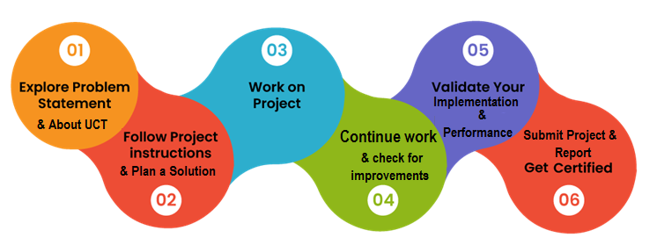

**My Learnings and overall experience.**

Throughout this internship I have come across varieties of application and learnt various programming language it also may us to be punctual as it has a time limit to submit all the reports along with the report it helped me to showcase talent and learn new things and develop a project in app development which is currently booming. It exposed me to industrial based project and it’s a great platform for me as it’s my first internship.

**I would like to tanks for the guidance given by**

**Upskill campus Kaushlendra Singh Sisodia, Ankith, Apurv**

**My message to your juniors and peers.**

* Gain real-world experience in your field
* Learn and grow as an individual
* Gain valuable skills that will help you succeed in the future
* Fulfill college requirements
* Add material to your resume

**What you should keep in mind**

* Complete your project on time
* Attend the quiz
* Go through the source provided clearly

# Introduction

## 

## About UniConverge Technologies Pvt Ltd

A company established in 2013 and working in Digital Transformation domain and providing Industrial solutions with prime focus on sustainability and RoI.

For developing its products and solutions it is leveraging various**Cutting Edge Technologies e.g. Internet of Things (IoT), Cyber Security, Cloud computing (AWS, Azure), Machine Learning, Communication Technologies (4G/5G/LoRaWAN), Java Full Stack, Python, Front end**etc.

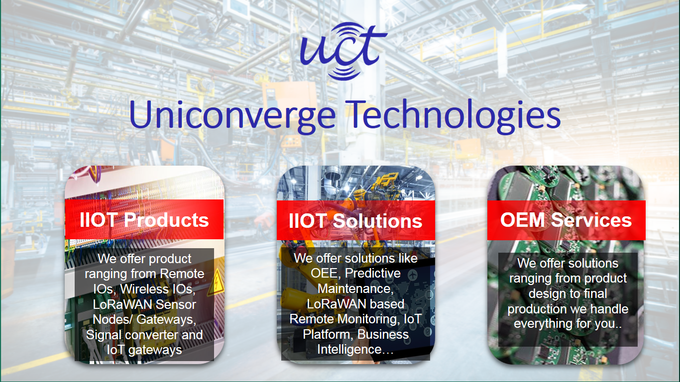

1. UCT IoT Platform **(****)**

**UCT Insight** is an IOT platform designed for quick deployment of IOT applications on the same time providing valuable “insight” for your process/business. It has been built in Java for backend and ReactJS for Front end. It has support for MySQL and various NoSql Databases.

* It enables device connectivity via industry standard IoT protocols - MQTT, CoAP, HTTP, Modbus TCP, OPC UA
* It supports both cloud and on-premises deployments.

It has features to  
• Build Your own dashboard  
• Analytics and Reporting  
• Alert and Notification  
• Integration with third party application(Power BI, SAP, ERP)  
• Rule Engine

 

1. **Smart Factory Platform (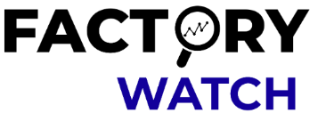)**

Factory watch is a platform for smart factory needs.

It provides Users/ Factory

* with a scalable solution for their Production and asset monitoring
* OEE and predictive maintenance solution scaling up to digital twin for your assets.
* to unleased the true potential of the data that their machines are generating and helps to identify the KPIs and also improve them.
* A modular architecture that allows users to choose the service that they what to start and then can scale to more complex solutions as per their demands.

Its unique SaaS model helps users to save time, cost and money. 

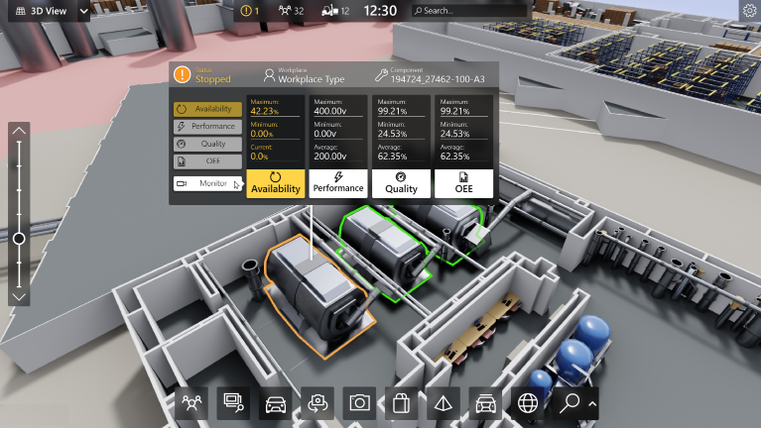

1. 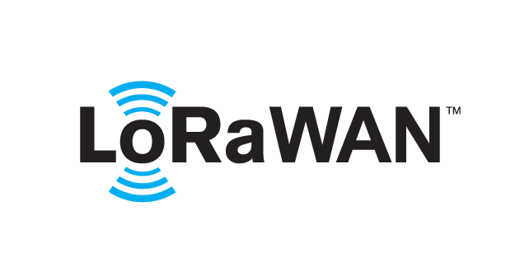 based Solution

UCT is one of the early adopters of LoRAWAN technology and providing solution in Agritech, Smart cities, Industrial Monitoring, Smart Street Light, Smart Water/ Gas/ Electricity metering solutions etc.

1. Predictive Maintenance

UCT is providing Industrial Machine health monitoring and Predictive maintenance solution leveraging Embedded system, Industrial IoT and Machine Learning Technologies by finding Remaining useful life time of various Machines used in production process.



## About upskill Campus (USC)

upskill Campus along with The IoT Academy and in association with Uniconverge technologies has facilitated the smooth execution of the complete internship process.

USC is a career development platform that delivers **personalized executive coaching** in a more affordable, scalable and measurable way.

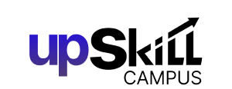

Seeing need of upskilling in self paced manner along-with additional support services e.g. Internship, projects, interaction with Industry experts, Career growth Services

<https://www.upskillcampus.com/>

upSkill Campus aiming to upskill 1 million learners in next 5 year

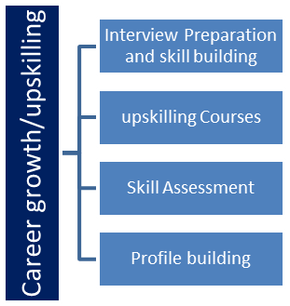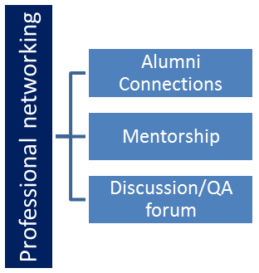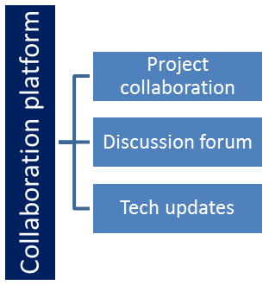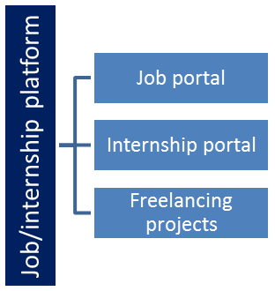

## 2.1The IoT Academy

The IoT academy is EdTech Division of UCT that is running long executive certification programs in collaboration with EICT Academy, IITK, IITR and IITG in multiple domains.

## 2.2Objectives of this Internship program

The objective for this internship program was to

 ☛ get practical experience of working in the industry.

 ☛ to solve real world problems.

 ☛ to have improved job prospects.

 ☛ to have Improved understanding of our field and its applications.

 ☛ to have Personal growth like better communication and problem solving.

## 2.2Reference

[1] Upskill discussion forum

[2] GitHub

[3] google

[4] YouTube

# Problem Statement

* High deployment and maintenance costs
* Lack of sufficient infrastructure to support smart metering
* Lack of skills
* Interoperability issues
* Weak communication signals in some locations

# Existing and Proposed solution

**Attempted Challenge:** Smart Water Metering

**Challenge Description**: AI-ML enabled Smart water metering to monitor water usage across areas and raise alarm in case of excessive and/or continuous water usage in a particular area.

**Proposed Solution Name:** Smart Water Usage Monitor

**Brief Background of Proposed Solution:** It has been observed that, in households huge amount of water is wasted through devices (i.e. Taps) daily which are a threat to the ground water source. Also, leakages in Distribution lines go unnoticed which results in wastage of significant amount of water.

The focus of our solution is to monitor the water usage of devices (i.e. Taps) in households, detecting any leakages in distribution line and raising alarm in case of excessive water usage or leaks in distribution lines.

**Objective:**

• Using a machine learning model to record and learn the trend of water usage in a certain area.

• Based on the above trained model, deciding whether there is excessive water usage in that area on daily basis.

• Detecting leakages in distribution lines if any.

• If excessive use or leakages is observed, an alarm is raised.

What value addition are you planning?

## Code submission

## <https://github.com/deekshaga/upskillcampus.git>

## Report submission (GitHub link) : <https://github.com/deekshaga/upskillcampus/upload/main>

<https://github.com/deekshaga/upskillcampus/commit/31ef7a206abf828b48634ed4a48b8482cc9fb977>

# Proposed Design/ Model

**Brief Description about the Concept**:

First, sample amount of data (i.e. for few years) are to be collected from the respective authority for learning the trend of water usage in a particular area and train the Machine learning model for the first time so that it can decide on the usage if it exceeds normal water usage. These data will be stored in a database (in our project it is cloud) for both decision and further training the Machine Learning model. After deciding if the water usage is abnormally high, alarm will be raised on authority end and also to the consumer (i.e. household owner) end that abnormal water usage is observed and based on that authority can take necessary actions. For detecting the leaks in distribution lines, the IoT based flow meters can be placed after regular distances in distribution lines and flow can be monitored at each point. If there is a significant difference of flow at two different points, alarm will be raised signifying a leak at the location between the two respective flow meters identifiable by their unique ID’s (As they are IoT based, each device has an unique ID associated with it). The authority can take required actions to repair the distribution lines. The flow meters will be connected and supervised through a Web application which will contain the database, the machine learning model and the detailed heuristics of water usage over different areas based on the learning of the model.

## High Level Diagram (if applicable)

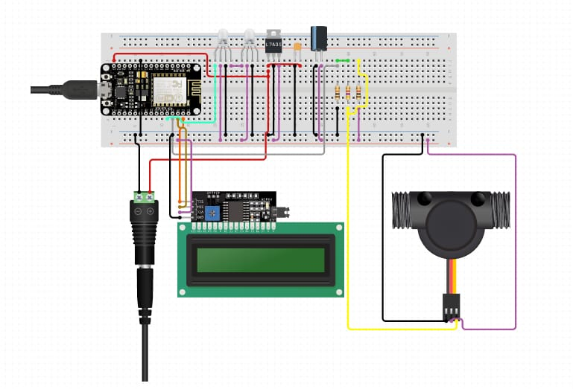

Figure 1: HIGH LEVEL DIAGRAM OF THE SYSTEM

## Low Level Diagram

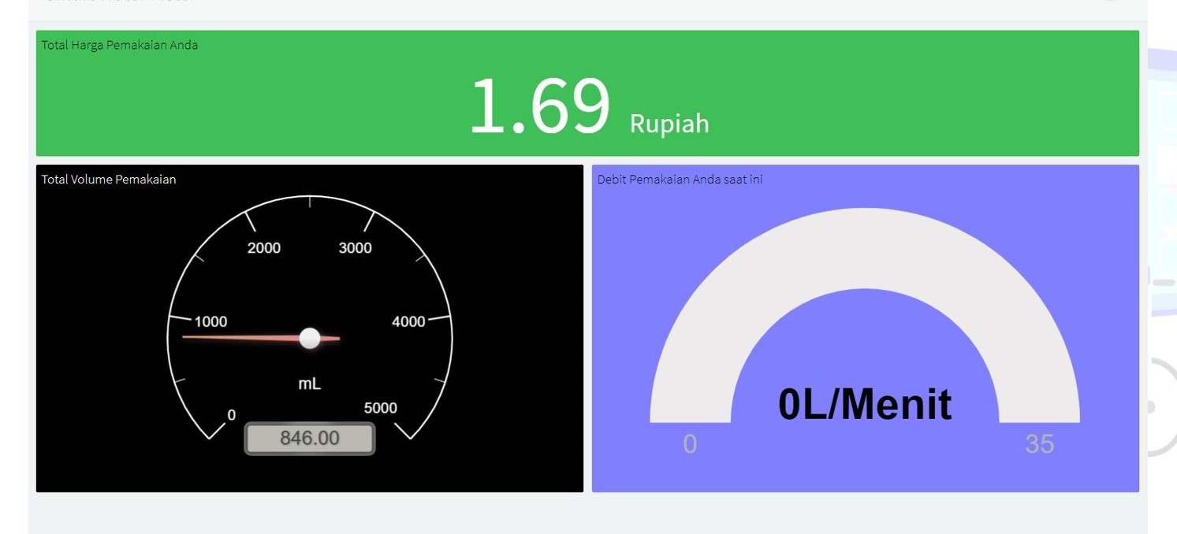Interfaces (if applicable)

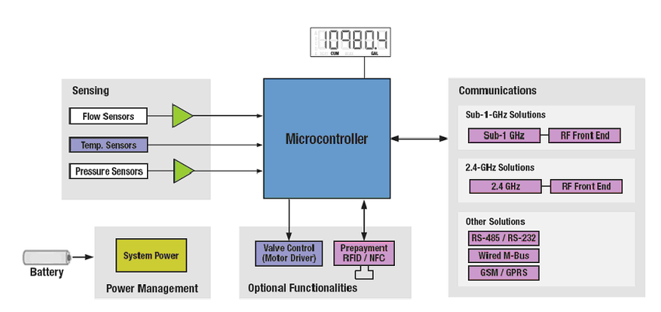

* 1. **Performance Test**

This is very important part and defines why this work is meant of Real industries, instead of being just academic project.

A water meter is a device that is used to track water usage. It helps,**not just in monitoring consumption but also to save money incurred on electricity used to pump the water and also energy consumption for functioning of sewage treatment plants.**

Here we need to first find the constraints.

How those constraints were taken care in your design?

A smart water meter works by tracking water usage through technology, which provide accurate measurements. Smart water meters use wireless technology, so readings are taken remotely and can provide frequent and accurate data 24/7. This means that users can go online to see their exact water consumption. This gives them greater control of their water use and their bills.

What were test results around those constraints?

**Smart Water meter** creates a two-way communication channel between user and provider to share information with each other that empower both parties to take useful and practical actions. IoT enabled water meters helps to reduce water losses in the entire water distribution network and allow utilities to track and manage the demand for water.

Constraints

1. A traditional water meter requires you to take **manual meter readings**, and submit them to your supplier by calling them, inputting them on your online account, or even by sending them through the post.
2. A smart water meter submits **automatic readings** frequently throughout the day without you having to lift a finger.
3. A smart water meter also has a **digital display** instead of a **traditional dial** so you can see how much water you're using at any given time.
4. Where the meter serial number would be located **above the meter reading** on a traditional meter, on a smart water meter this may be located above a barcode, which is often **below the meter reading**.

**Test Plan/ Test Cases**

Type Test : Series of tests carried out on meters of the same type having identical characteristics, selected by manufacturer to prove conformity with all the requirements of Standard for the relevant class of meter. These are intended to prove the general qualities & design of a given type of meter. Routine Test : Tests carried out on each meter to check conformity with the requirements of standard in aspects which are likely to vary during production. Acceptance test : Test carried out on Samples taken from a lot for the purpose of acceptance of the lot. Number of Samples and Criteria for Conformity • Type tests shall be applied to 3 test specimens. In the event of 1 specimen failing to comply in any respect, further 3 specimen shall be taken all of which shall comply with the requirement of the standard. • For Test of Load Switch, 1 Sample in case of Load Switch Utilization Category UC1 and 4 samples in case of Load Switch Utilization Category UC2/UC3 • For Data Exchange protocol and Smart meter communicability test, 1 Sample

**Performance outcome**

It is suggested that on average, having a smart water meter installed in your home can increase your water usage efficiency by **up to 12%**

# My learnings

IoT and smart meters have already become important in the energy sector and have had a big impact on the amount of energy we consume. With considerable environmental and social benefits, smart meters could also change the way we use water. Rolling them out more prolifically could help us to reach net zero and conserve water, whilst saving vast amounts of money for water utilities and customers.

# Future work scope

Developing stronger relationships with customers and raising awareness of smart meters and their importance in the future of water sustainability will be essential for water utilities if they are going to raise awareness for water sustainability.

IoT smart meters can also make a huge impact for businesses. In factory and plant settings, smart meters can be fitted with a valve which can be controlled remotely. The water flow can therefore be controlled and can be programmed to shut off completely at certain times. This gives companies complete control, allowing them to manage their water consumption more effectively, saving them money and streamlining their operational processes.

Smart meters improved accuracy helps water utilities reduce non-revenue water levels. With less accurate metering, a lot of water is unaccounted for due to meter inefficiency, as well as leaks, theft and breaks in the main water supply pipeline. By using smart meters, water utilities will be able to greatly reduce non-revenue water, having huge cost benefits. The money saved from this can be used to improve infrastructure and help water utilities create robust plans to support a growing population.

The benefits of rolling out smart meters across the country and indeed the world, are far reaching. A large shift to smart water meters will have long-lasting benefits for the environment. The financial benefits are also strong and will hopefully be enough to encourage water utilities and their customers to make the switch.

With new and compelling IoT applications constantly emerging in the energy and water sectors, together they can make a considerable contribution to sustainability. By making small, consistent changes, utilities can help to secure a sustainable future for water.